Digital Experience **Volunteers**

**PURPOSE:**

Enable Digital colleagues to contribute to the strategic alignment and enablement of the enterprise digital transformation while leveraging their passions, strengths and interests.

**OVERVIEW:**

Born out of the People & Culture volunteer committee, this is an opportunity to partner with Transformation, Culture & Communications (TCC) to contribute to the strategic alignment and enablement of the enterprise digital transformation. This directly impacts one of the priorities connected to our 2023 Digital Priorities – Be purpose-driven, human-centered and lead with courage as well as enable us to be energized by our culture and continue to deliver more value more quickly through strategic execution.

While making a meaningful difference to our Digital colleagues, division and firm, you'll also get hands-on experience leading people and delivering the right results with and through others.

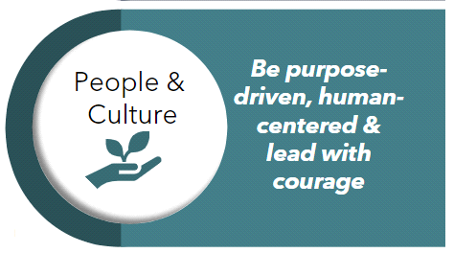As a Digital Experience Volunteer, you will:

* Influence strategies and appropriate measures of success.
* Contribute to the development and execution of the Transformation, Culture & Communications (TCC) 2023 roadmap.
* Lead, engage and inspire a group of committed and talented associate volunteers.
* Expand your network and partner with individuals across the firm.

BENEFITS:

You will stretch yourself and develop new ideas, skills and competencies that can serve your team, department and division in new and inspiring ways. Volunteers are expected to experience:

* Leading people in formal and informal roles.
* Exposure to new partnerships and ways to collaborate.
* Strategic planning through design thinking and workstream involvement.
* Learning about new technology and ways of working.
* Delivering the right results with and through others.

ROLES, RESPONSIBILITIES AND RECOGNITION:

When planning for your role and contributions in 2023, here are some resources to discuss with your leader:

* Documenting and recognizing your responsibilities and contributions in 2023:

❑ **SAMPLE OBJECTIVE #1:** Contribute to our division's objectives through the Digital Experience Volunteers to achieve *XX goal*.

❑ **SAMPLE OBJECTIVE #2:** Lead strategic contributions to department, division and firm initiatives that impact client outcomes, associate engagement and firm results, in order to achieve *XX goal*.

▪ **SAMPLE STRATEGY #1:** Actively serve on the <insert workstream> to develop and execute the 2023 roadmap.

▪ **SAMPLE STRATEGY #2:** Lead the *[insert name]* workstream, in order to [*fill in purpose…]*.

▪ **MEASURES:** *Developed with your help and based on workstream*

* Aligning your participation with your development plan and Key Development Action (KDA).
* Capturing your allocation of time each month in Clarity.

EXPECTATIONS:

**Engage**

* Understand our various audiences in a way that meets them "where they're at"
* Create engagement ideas to both maintain our current audience as well as increase our audience engagement
* Partner with other workstreams and leaders

**Lead**

* Make decisions for the workstreams
* Foster environment for creativity to bring in new ideas and/or modify our tried-and-true methods

**Strategize**

* Define actions, success metrics and outcomes
* Assign ownership and ensure communication streams to keep all workstreams/the whole campaign aligned

**Execute**

* Hold yourself and workstream accountable for executing on committed actions and progressing towards your success metrics and outcomes
* Ensure communication streams to keep all workstreams informed and aligned

TIME COMMITMENT:

The time and talent you contribute will vary by need in our 2023 Areas of Focus. Commitment length should be at least **1 trimester** and on average, **5-10% of your time per trimester**. You are encouraged to discuss your commitment with your leader prior to joining.

2023 AREAS OF FOCUS AND TCC ACCOUNTABLE LEADER:

**TCC Key Responsibilities:**​

* Increase Edward Jones Digital colleague engagement to ensure a desirable workplace – which will empower and equip Digital colleagues to deliver on our Digital Transformation.​
* Establish and enable an industry leading, award-winning Digital brand that helps us attract/retain talent, inspire branch and client confidence, and engage with our communities. ​